Assignment :1

Spring 2024: CS5720 Neural Networks & Deep Learning - ICP-1

Dheeraj Annam

Id:700759413

1. Write a python program for the following:

– Input the string “Python” as a list of characters from console, delete at least 2 characters, reverse the resultantstring and print it.

Code:

input_string = list(input("Enter a string: "))

if len(input_string) >= 2:

modified_string = input_string[:-2]

reversed_string = modified_string[::-1]

print(''.join(reversed_string))

else:

print("Please enter a string with at least 2 characters.")

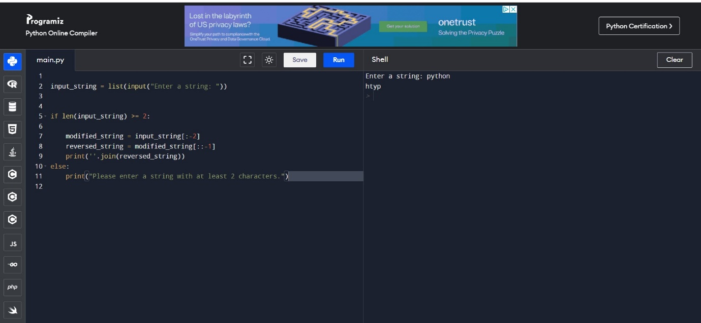

Task 1 Summary:

The program takes the input string "Python," converts it to a list of characters, deletes at least 2 characters, reverses the resulting string, and prints the reversed string.

2. Take two numbers from user and perform at least 4 arithmetic operations on them

num1 = float(input("Enter the first number: "))

num2 = float(input("Enter the second number: "))

addition = num1 + num2

subtraction = num1 - num2

multiplication = num1 * num2

division = num1 / num2

print("\nArithmetic Operations:")

print(f"{num1} + {num2} = {addition}")

print(f"{num1} - {num2} = {subtraction}")

print(f"{num1} * {num2} = {multiplication}")

print(f"{num1} / {num2} = {division}")

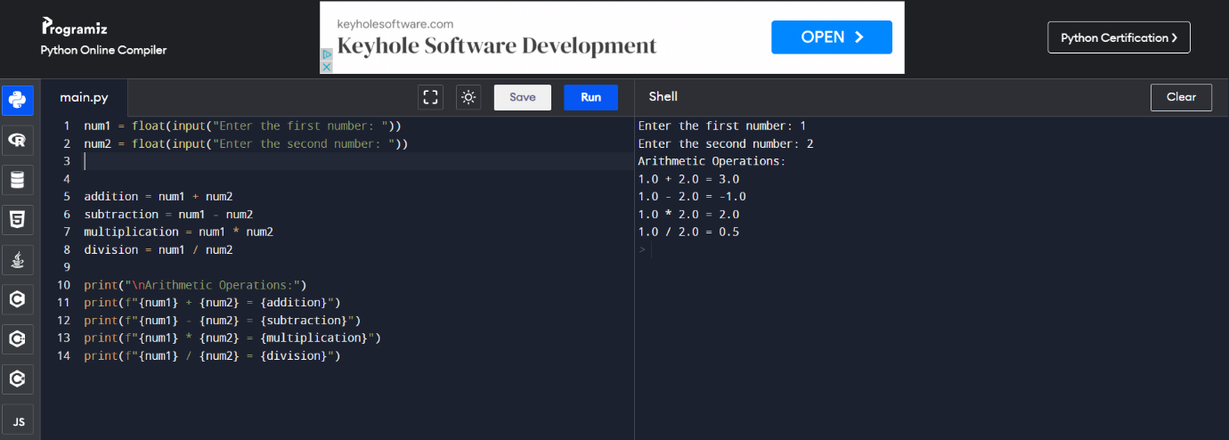

Task2 Summary:

This program prompts the user for two numbers, performs addition, subtraction, multiplication, and division operations on them, and prints the results.

3. Write a program that accepts a sentence and replace each occurrence of ‘python’ with ‘pythons’

sentence = input("Enter a sentence: ")

word_to_replace = input("Enter the word to replace: ")

replacement_word = input("Enter the replacement word: ")

modified_sentence = sentence.replace(word_to_replace, replacement_word)

print(modified_sentence)

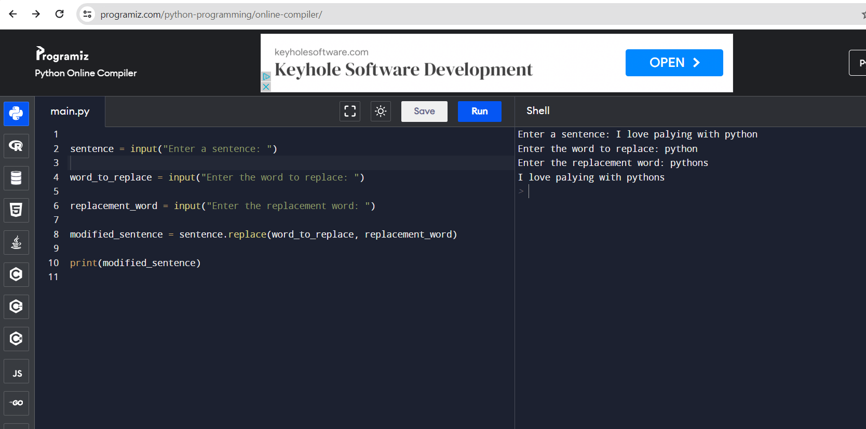

Task3 Summary:

The code accepts a sentence from the user, replaces each occurrence of 'python' with 'pythons,' and prints the modified sentence.

4. Use the if statement conditions to write a program to print the letter grade based on an input class score. Use the grading scheme we are using in this class.

class_score = float(input("Enter the class score: "))

if 90 <= class_score <= 100:

grade = "A"

elif 80 <= class_score < 90:

grade = "B"

elif 70 <= class_score < 80:

grade = "C"

else:

grade = "Below C"

print(f"Letter Grade: {grade}")

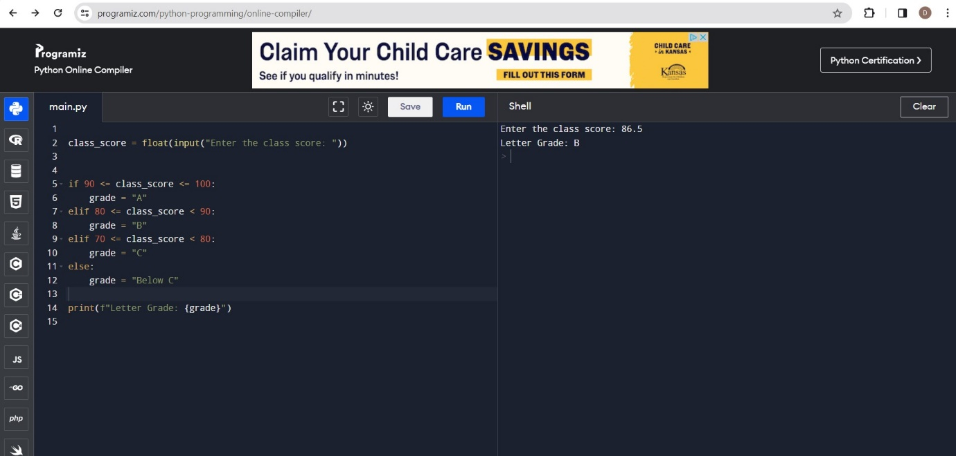

Task4 Summary:

Taking a class score from the user, the program uses if and elif conditions to determine the letter grade based on a grading scheme, and then prints the calculated letter grade.